**Abhiram Basa**

**Python Assessment - 5 - 16/12/23**

Topics covered:

* Map Function.
* String functions.
* Time modules and functions.
* Lambda Functions

Pass by reference and Pass by value:

When you modify the reference value passed to a function, it will also change the original value provided at the stage of calling a function.

But, when you assign new values to existing reference value then it won’t modify the original value provided at calling the function.

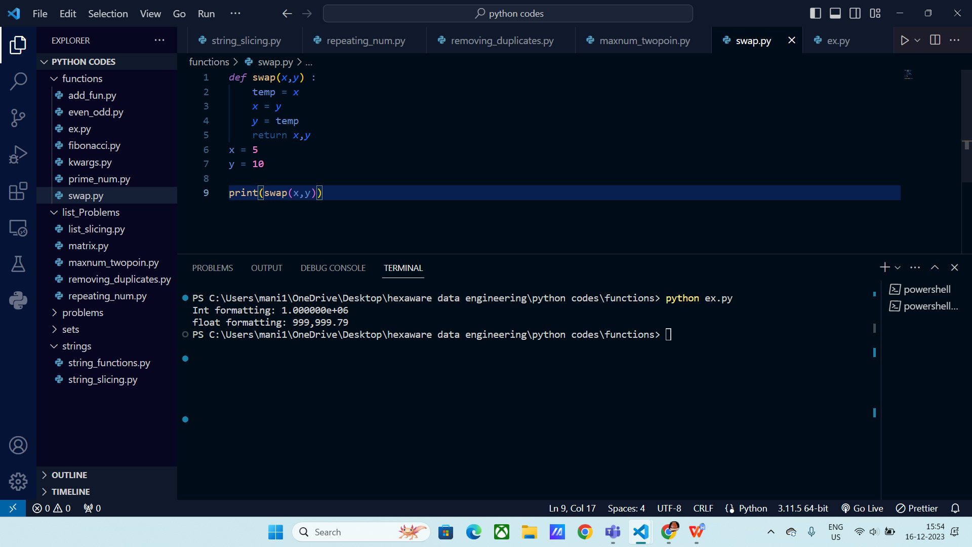

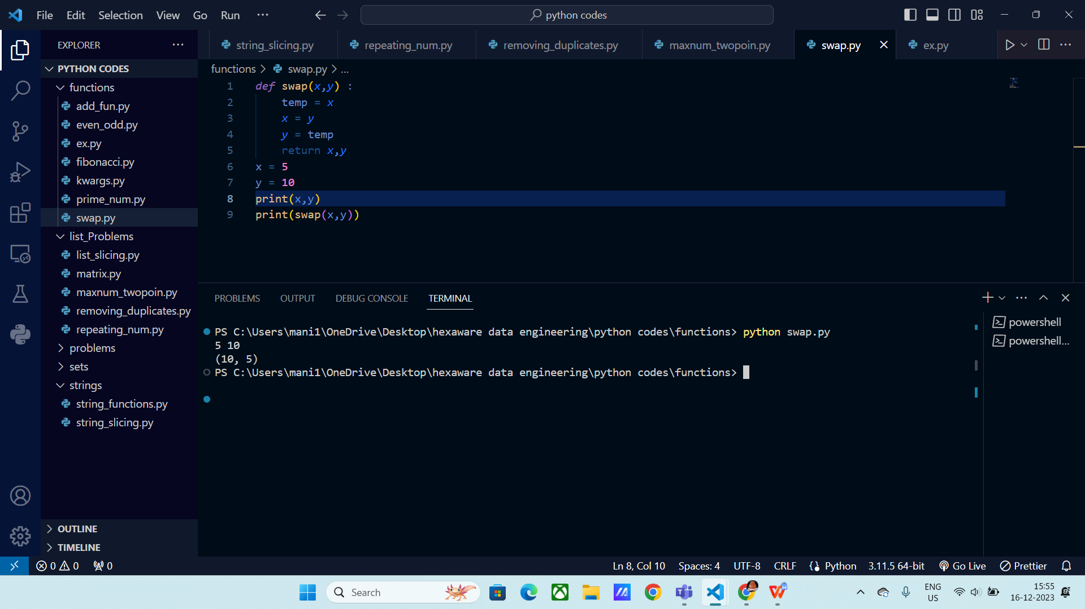

**Map Function () :**

Syntax:

Map (function,iterator)

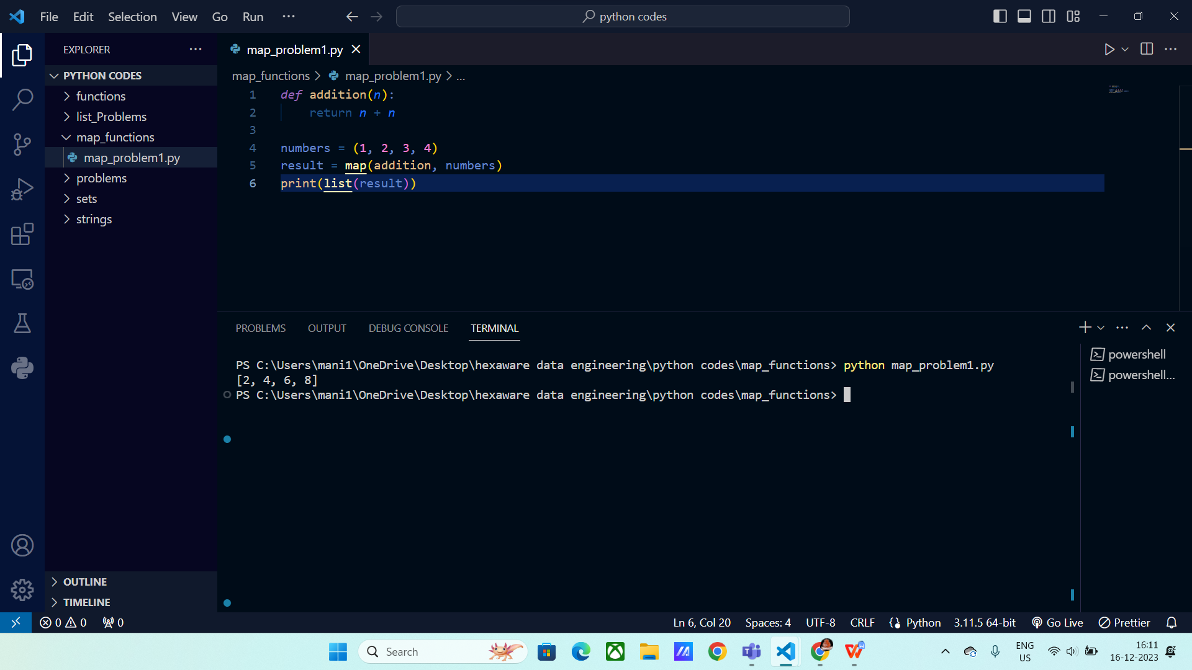

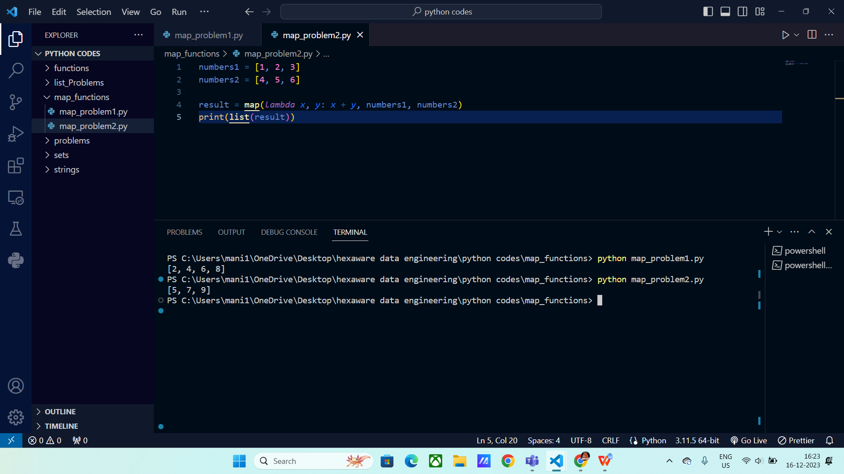

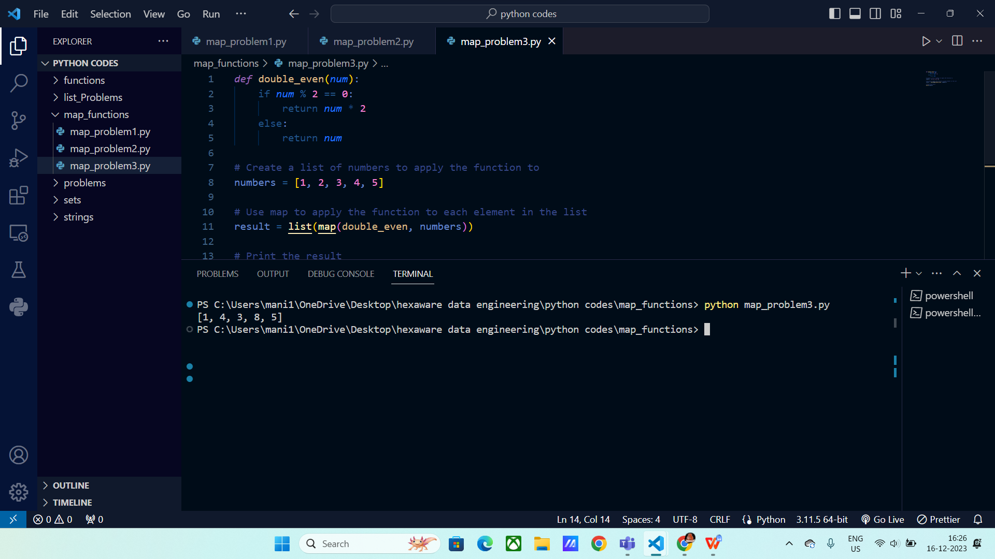

**String Functions:**

**Capitalize ():** It capitalize the starting letter of the sentence or word.

Syntax:

S1.capitalize()

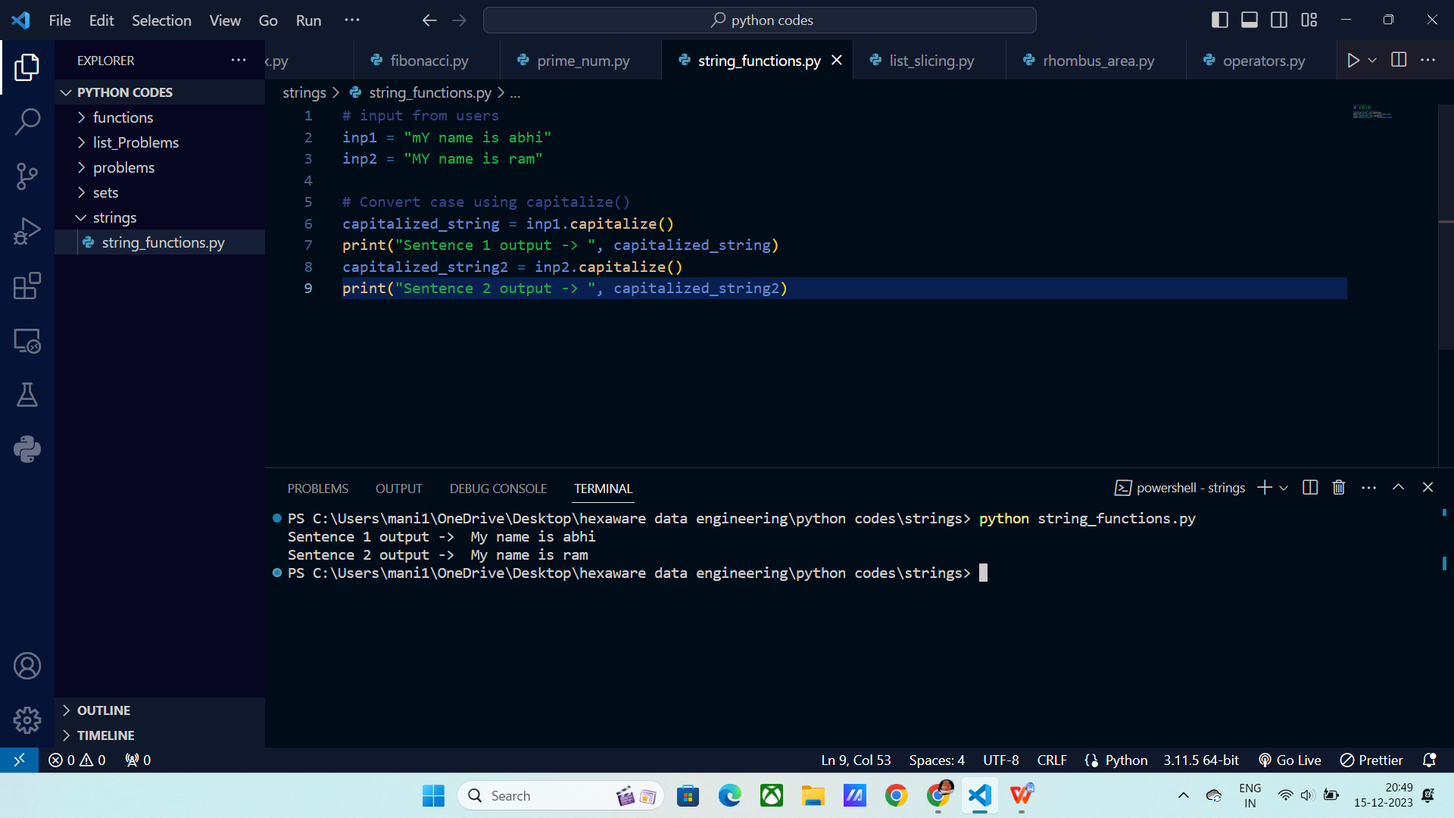

**Lower () :** It converts the input into lower case letters.

Syntax:

S1.lower()

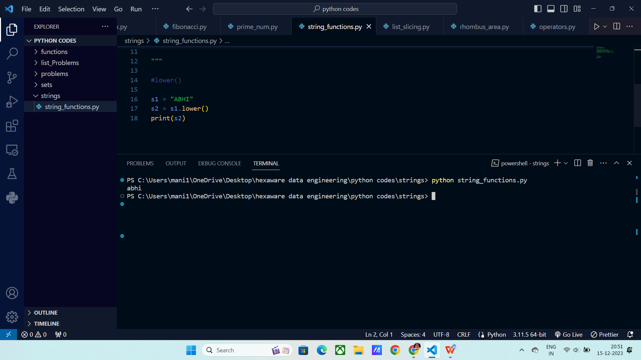

**Upper() :** It converts the input into upper case letters.

Syntax:

S1.upper()

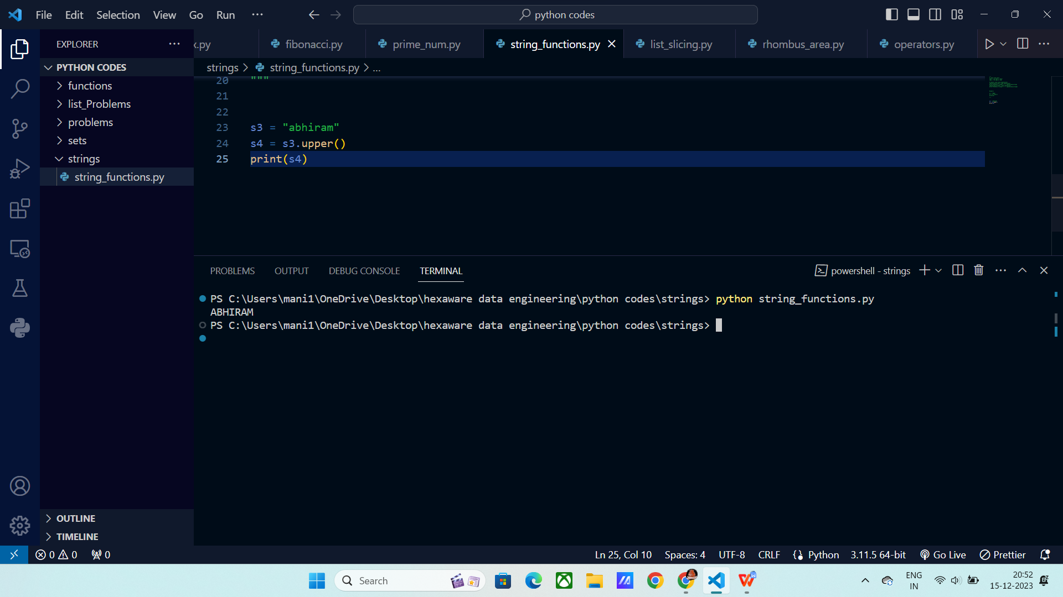

**Isalpha():** It checks whether the given input contains alphabets or not.

Syntax:

S1.isalpha()

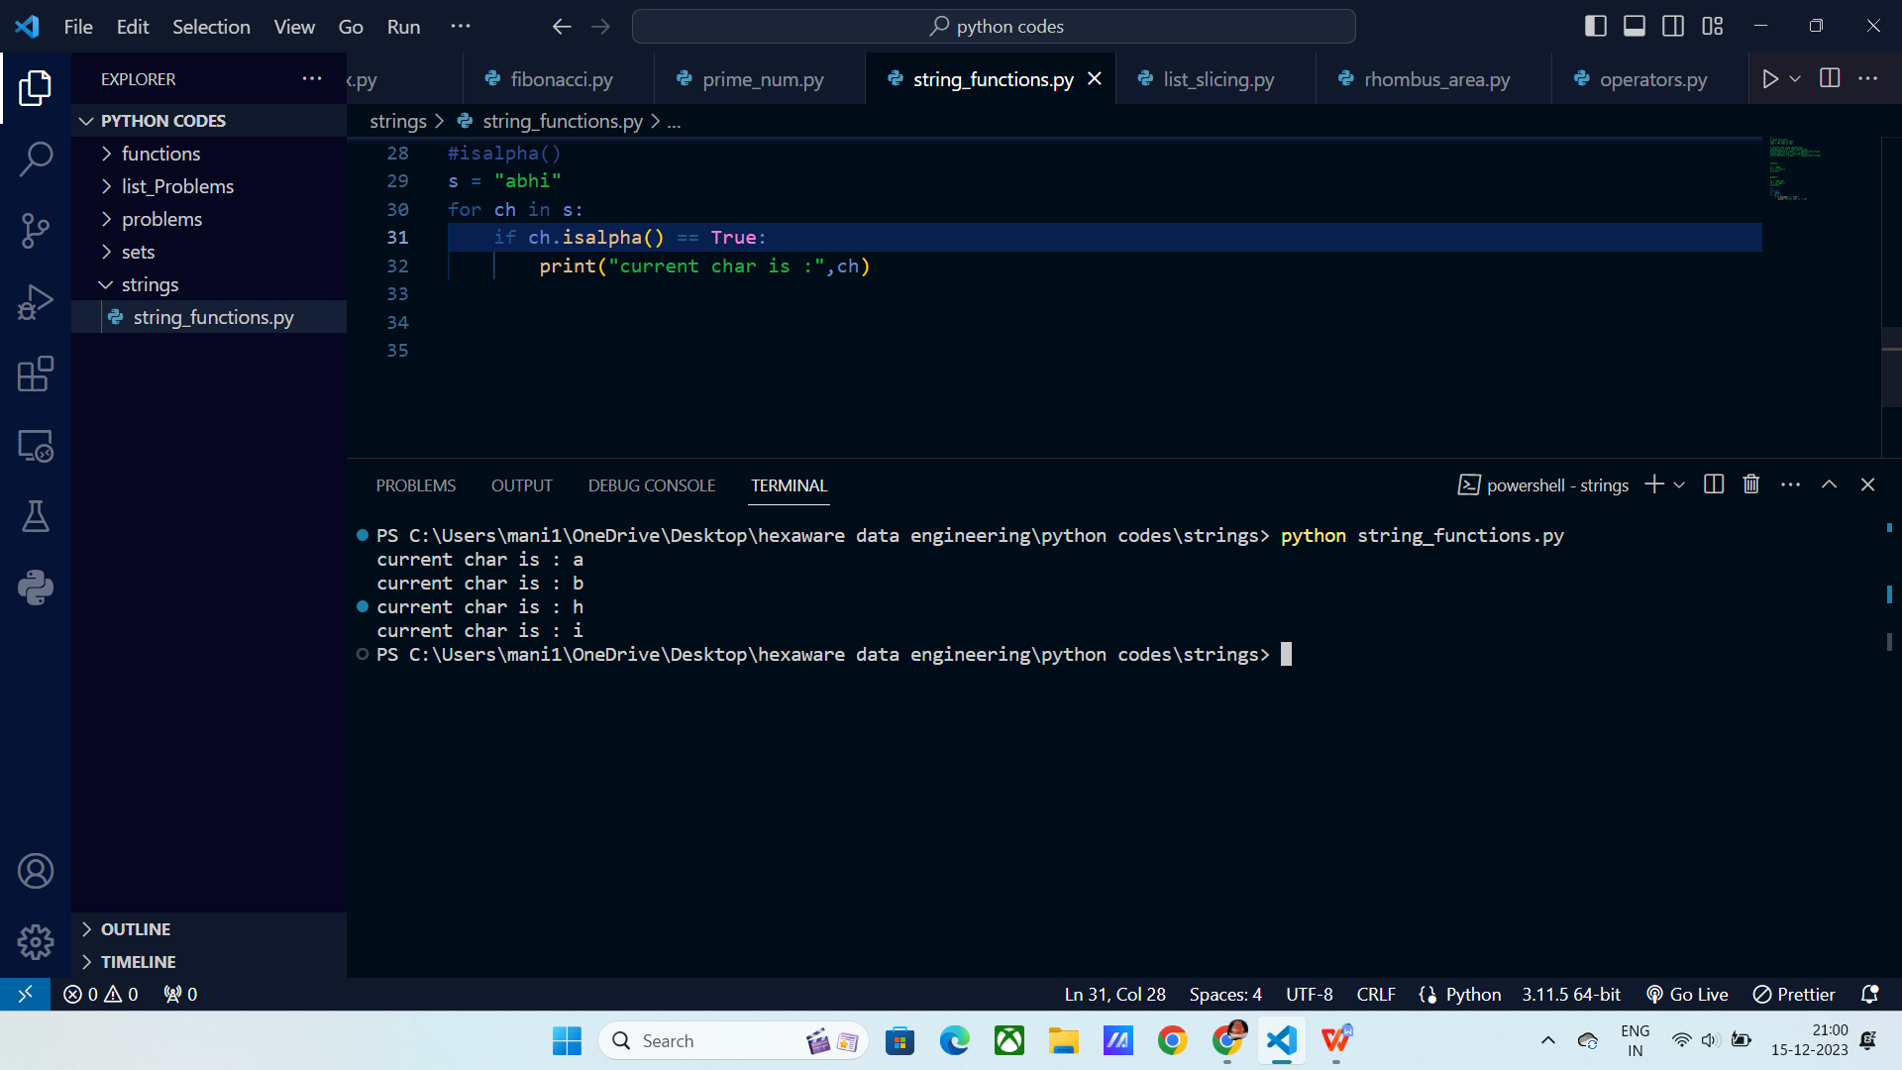

**Isalnum():** It checks whether the input contains both characters and numbers.

Syntax:

S1.alnum()

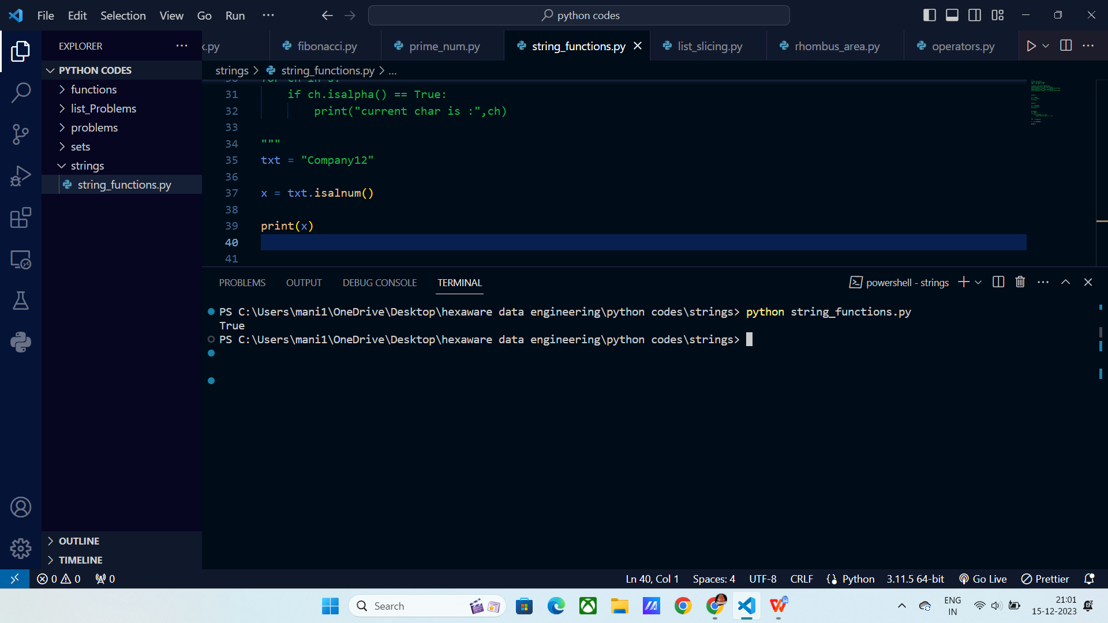

**Count():** It counts the specifies item occurrences.

Syntax:

Count(“input”)

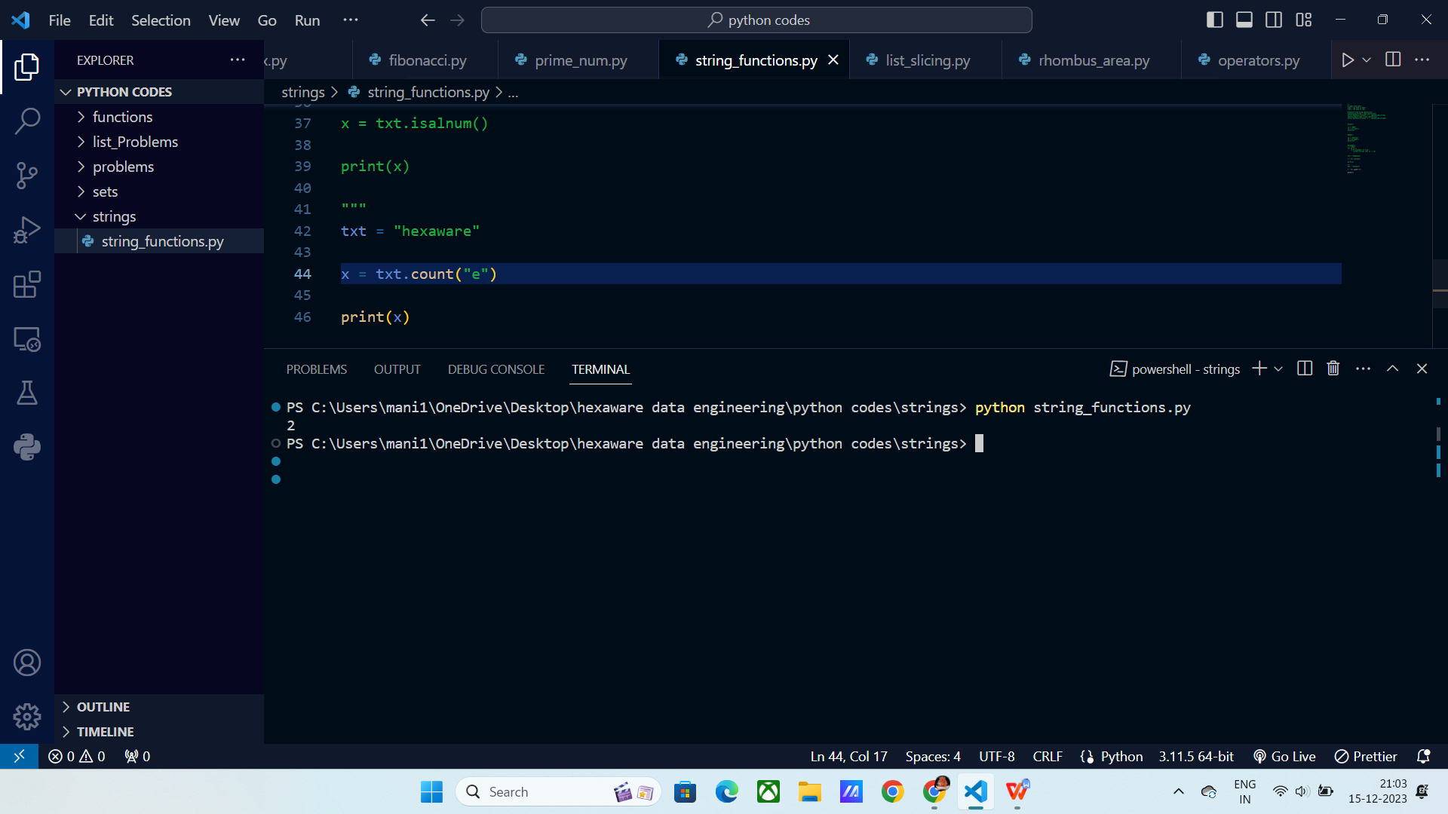

**Find():** It finds the first occurance of the input and returns the index.

Syntax:

Find(“input”)

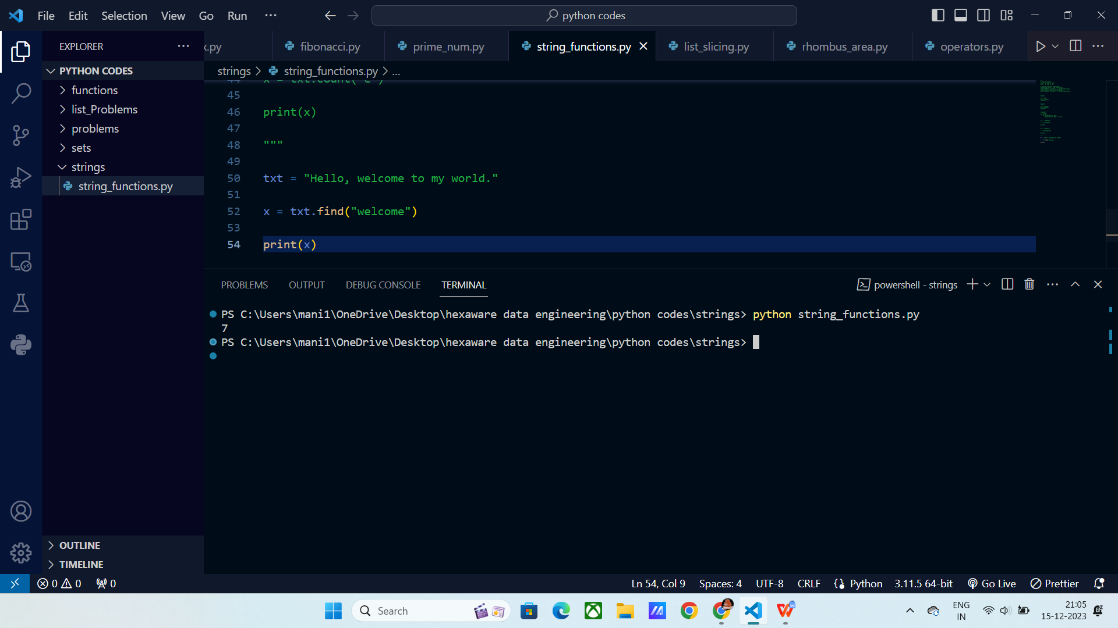

**Replace():** It replaces the mentioned value with given value.

Replace(“string”,” replaced string ”)

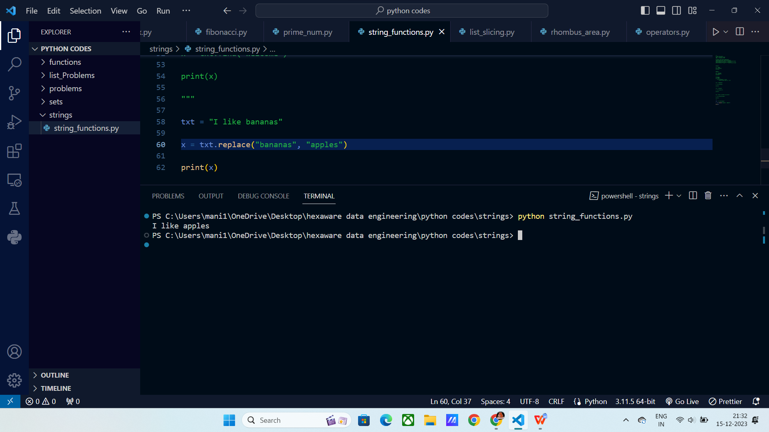

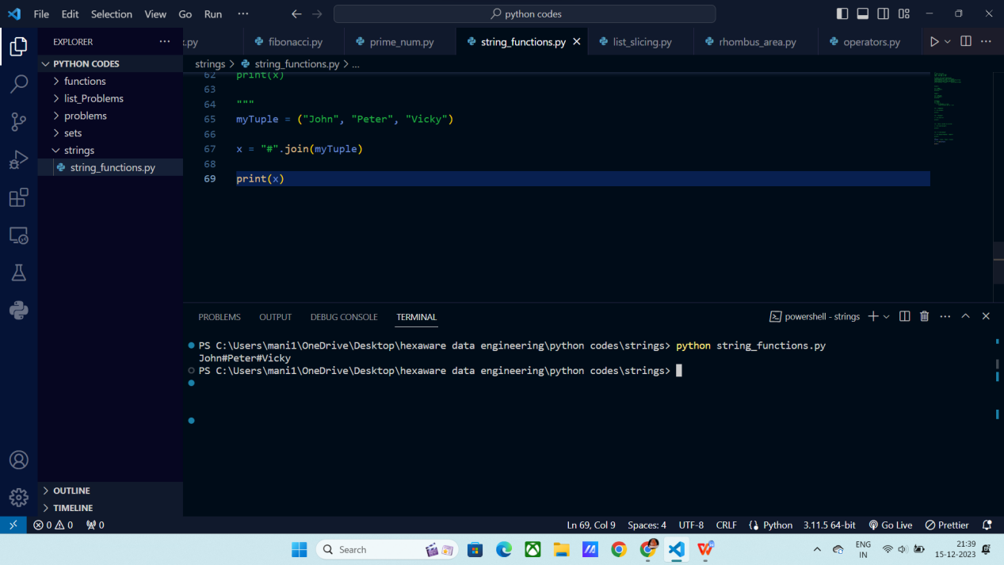

**Time modules and functions:**

**Time module :** It is a module that is already developed by some developer, in order to use it we need to import it.

It contains all the details related to time.

**Local time() :**

It gives you the current time stamp in your local system in terms of year, month, day, hour, minute and seconds.

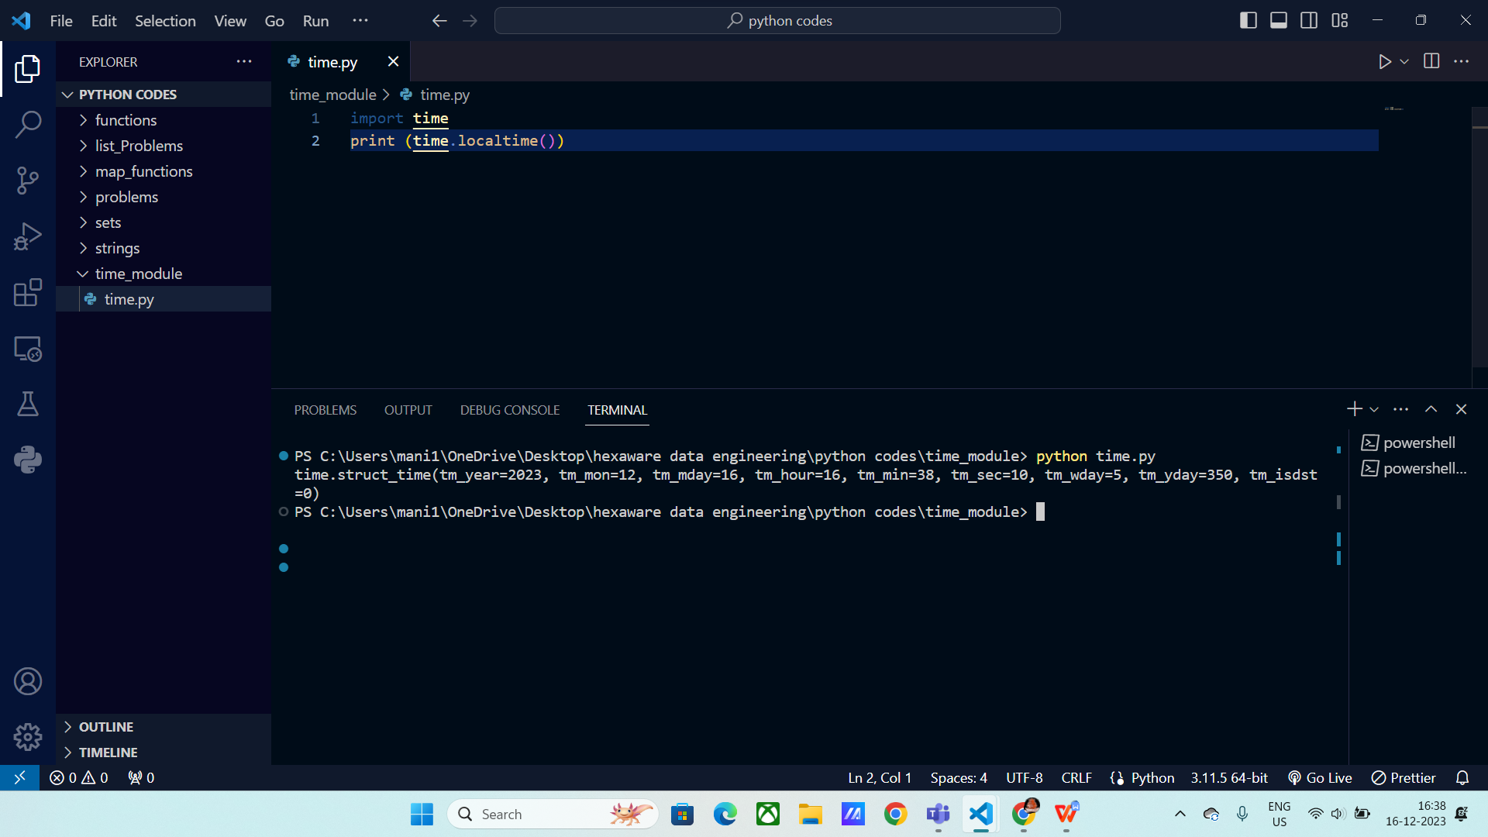

Asctime() : It will give you the time in a readable format.

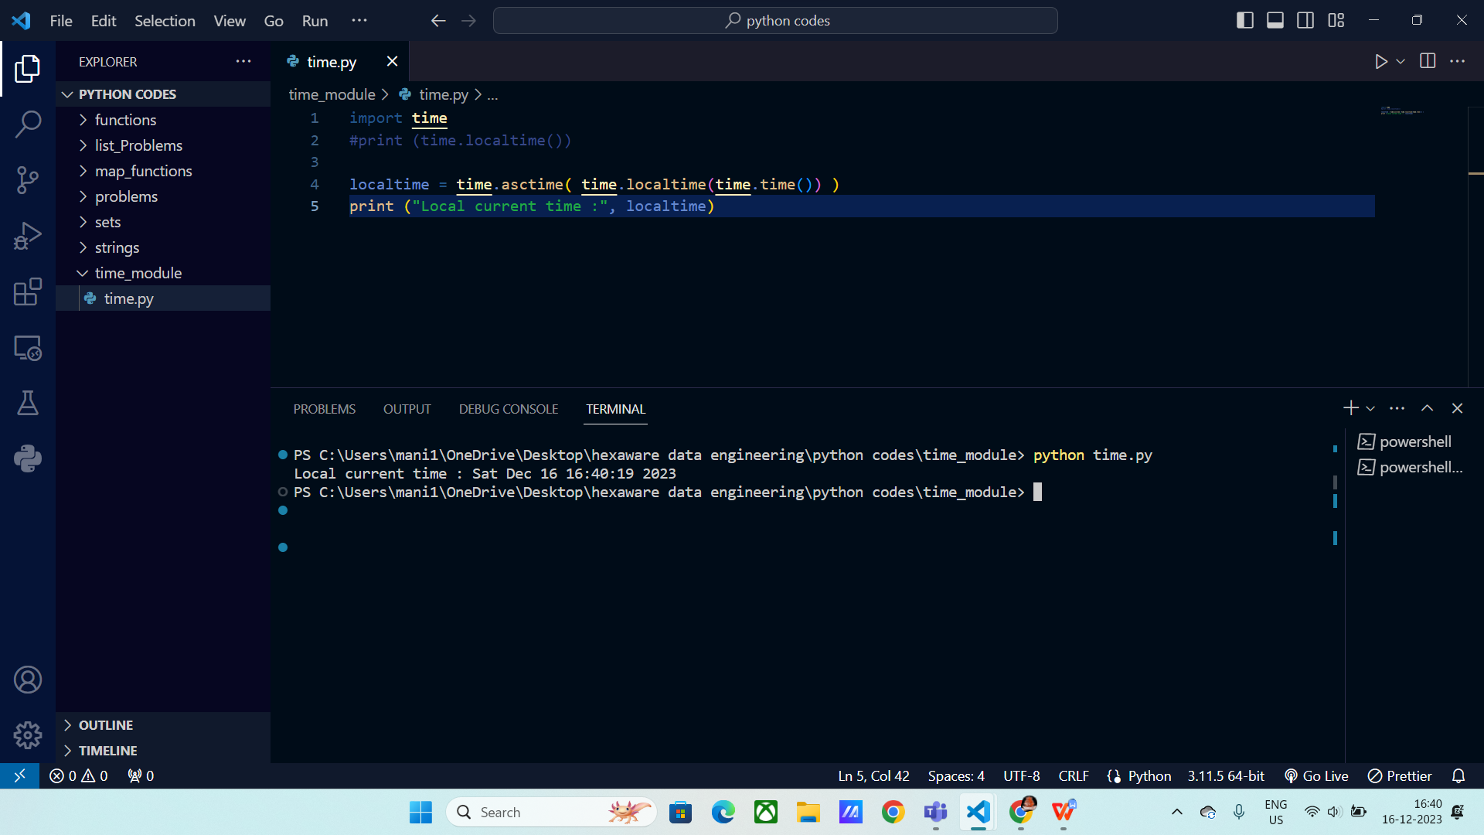

**Calendar :** It returns the calendar of the given input year.

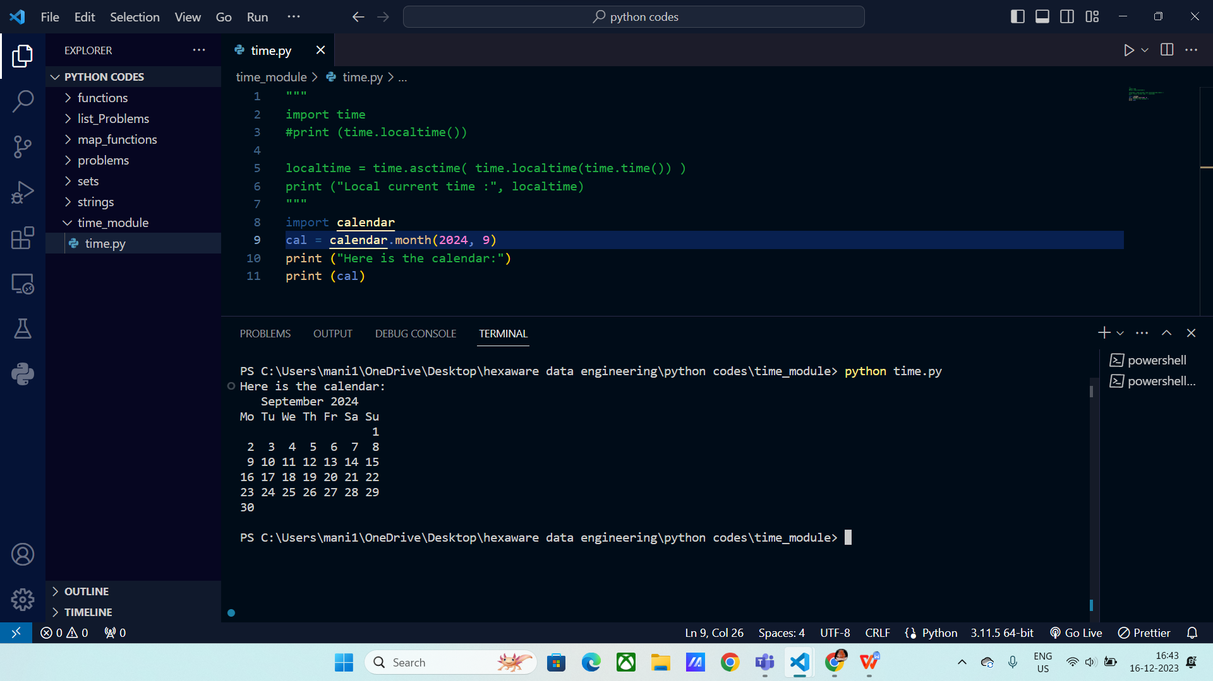

Min date() : It returns the minimum date possible.

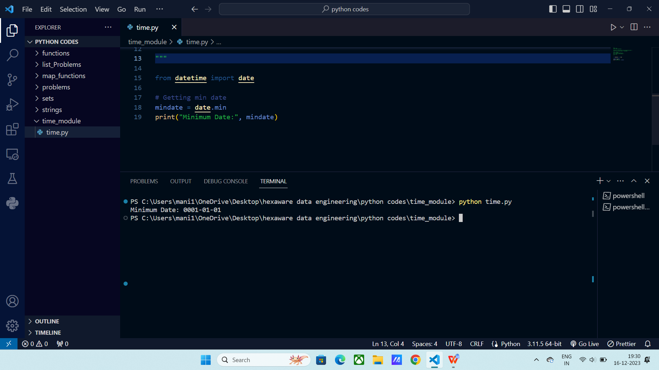

**Lambda function() :**

* Python Lambda Functions are anonymous functions. Lambda functions can be used to do when multiple lines of code must be execute at once.
* These can be used instead of functions.

Syntax :

Lambda Arguments : Expression

**Upper function using Lambda :**

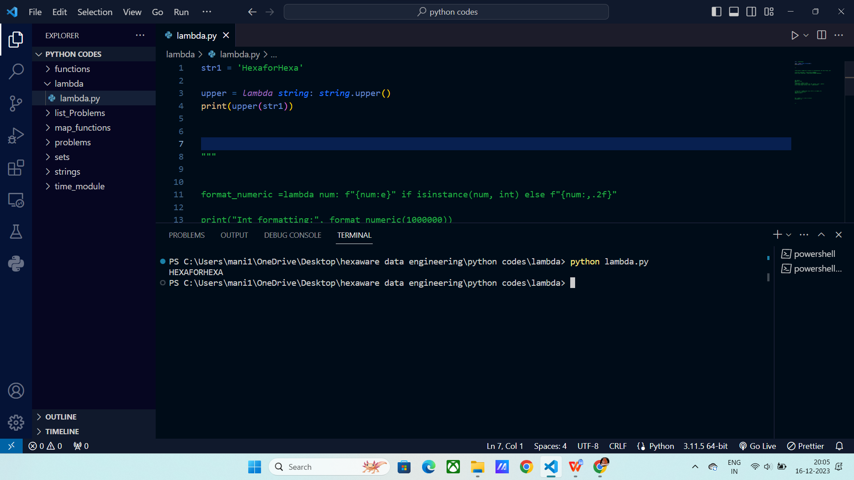

**Formatting string using Lambda :**

Here list comprehension is used, if the input is integer then it formats the input to exponential format and if the input is other than integer then it will format the input to floating data type.

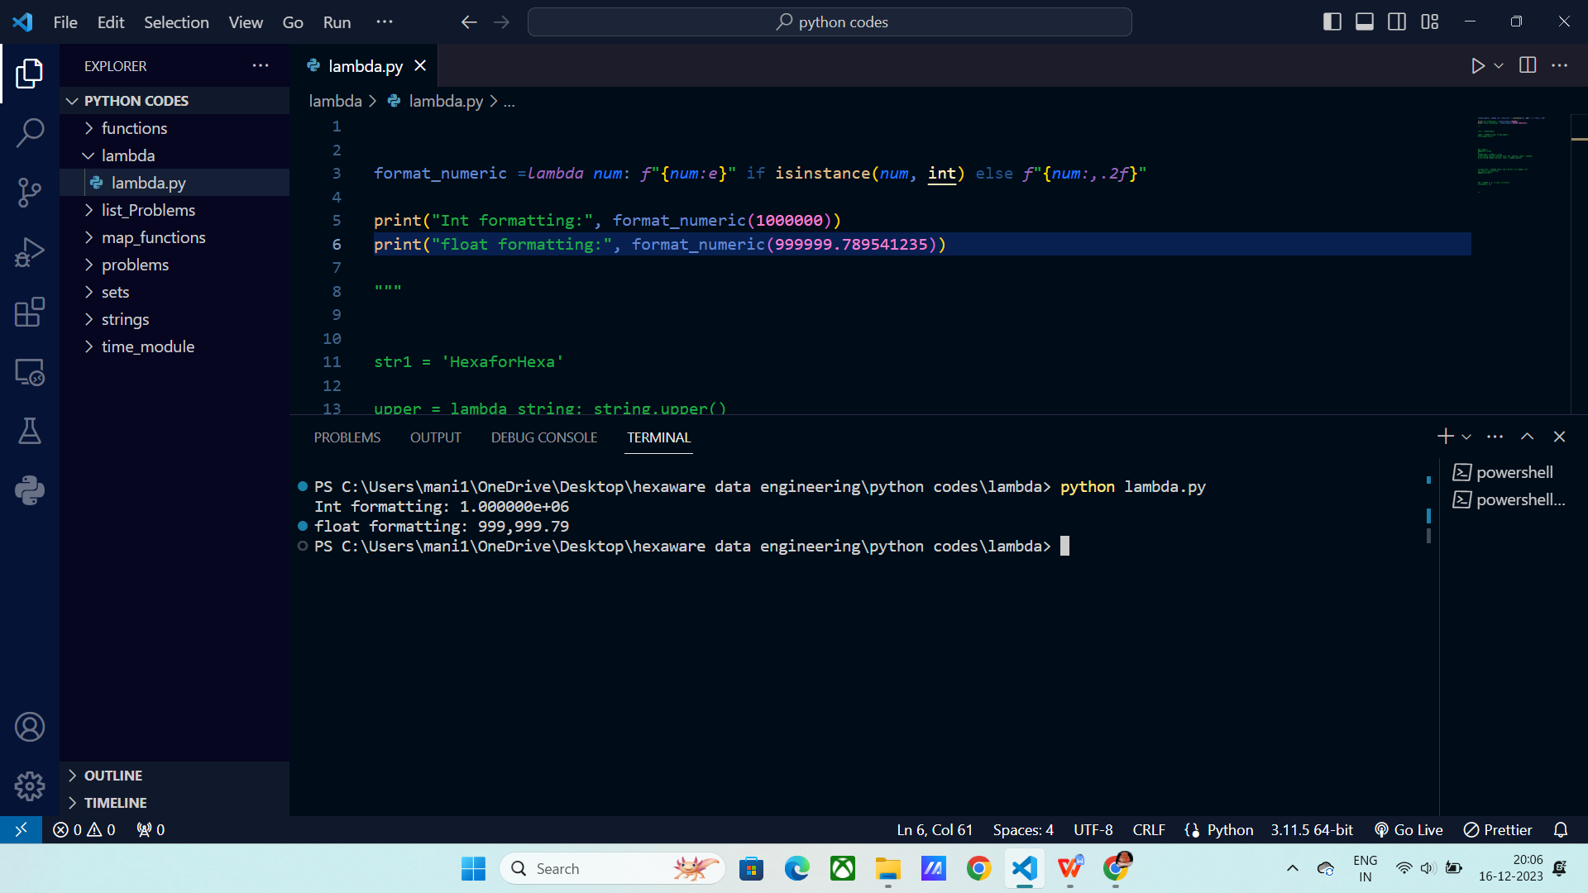

Finding cubes using lambda :

Here lambda and functions does the same job of calculating the cubes of input.

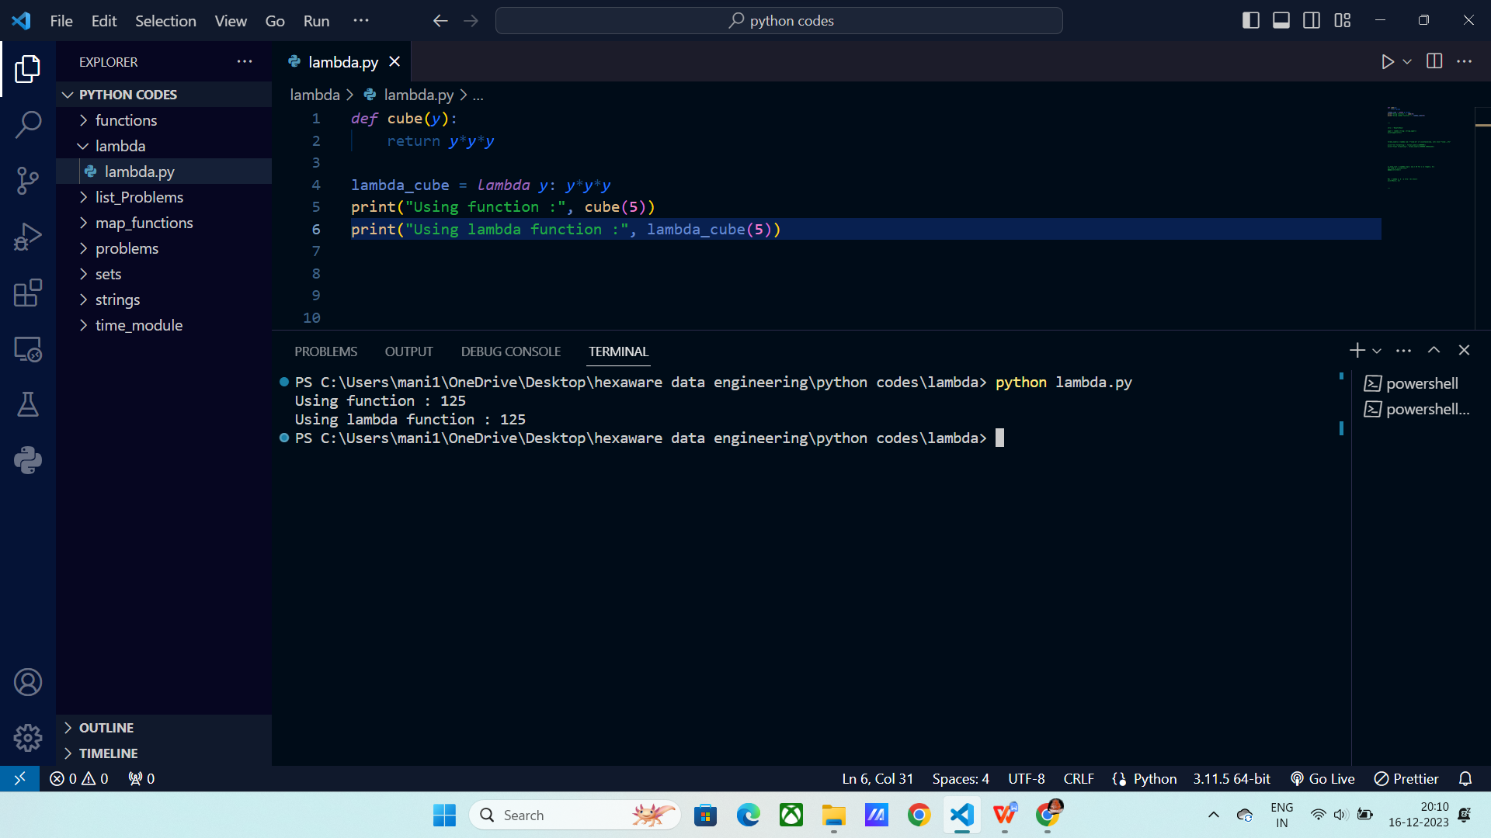

Using lambda in List :

Here it generates a list using list comprehension and the generated list is passed to lambda function and printing it with multiplying with 10.

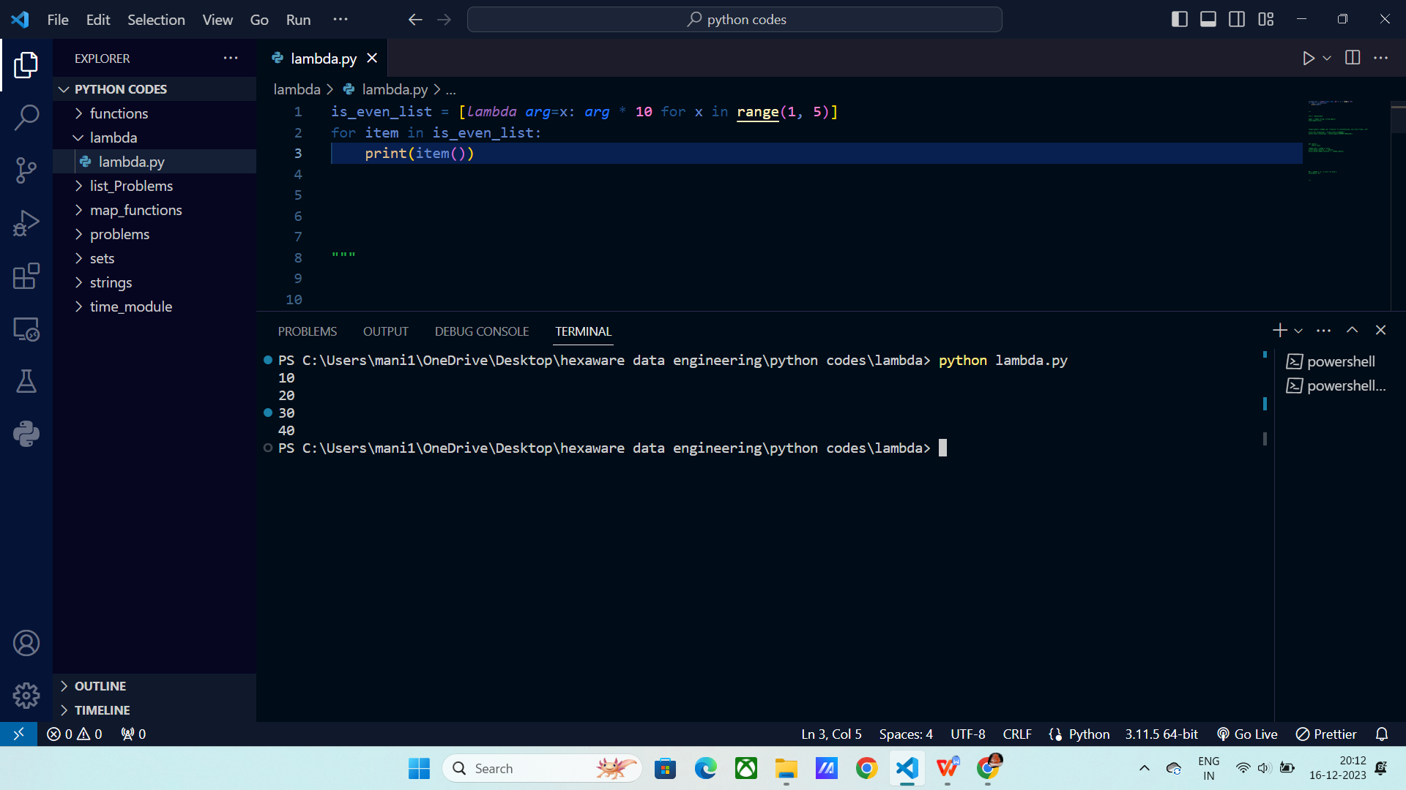

Finding max of two inputs using lambda function :

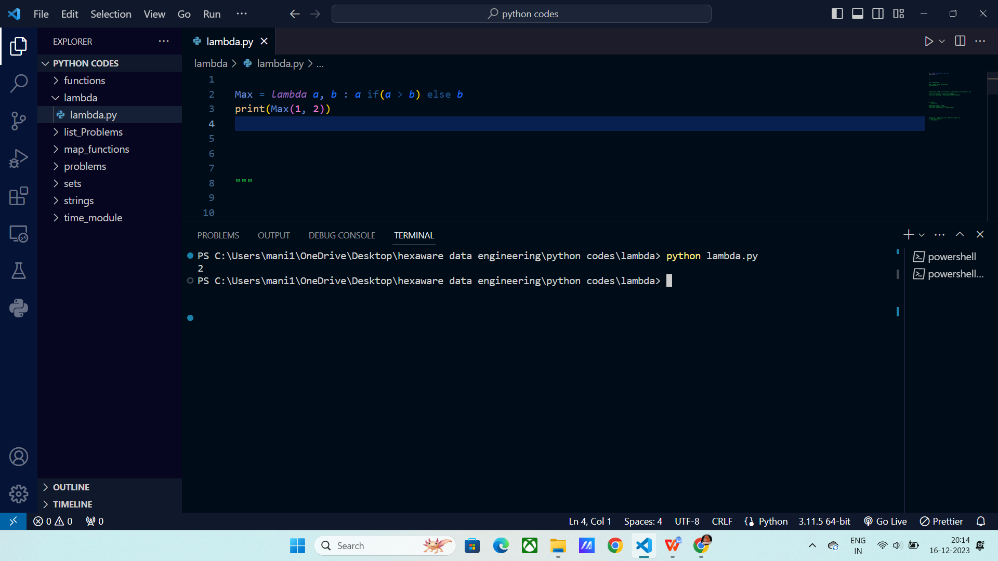

Using Filter with lambda:

Filter method is used to filter the input based on the condition.

Here the condition is that if the list elements which are not divisible by 2, then only it will print it else it will move to next element.

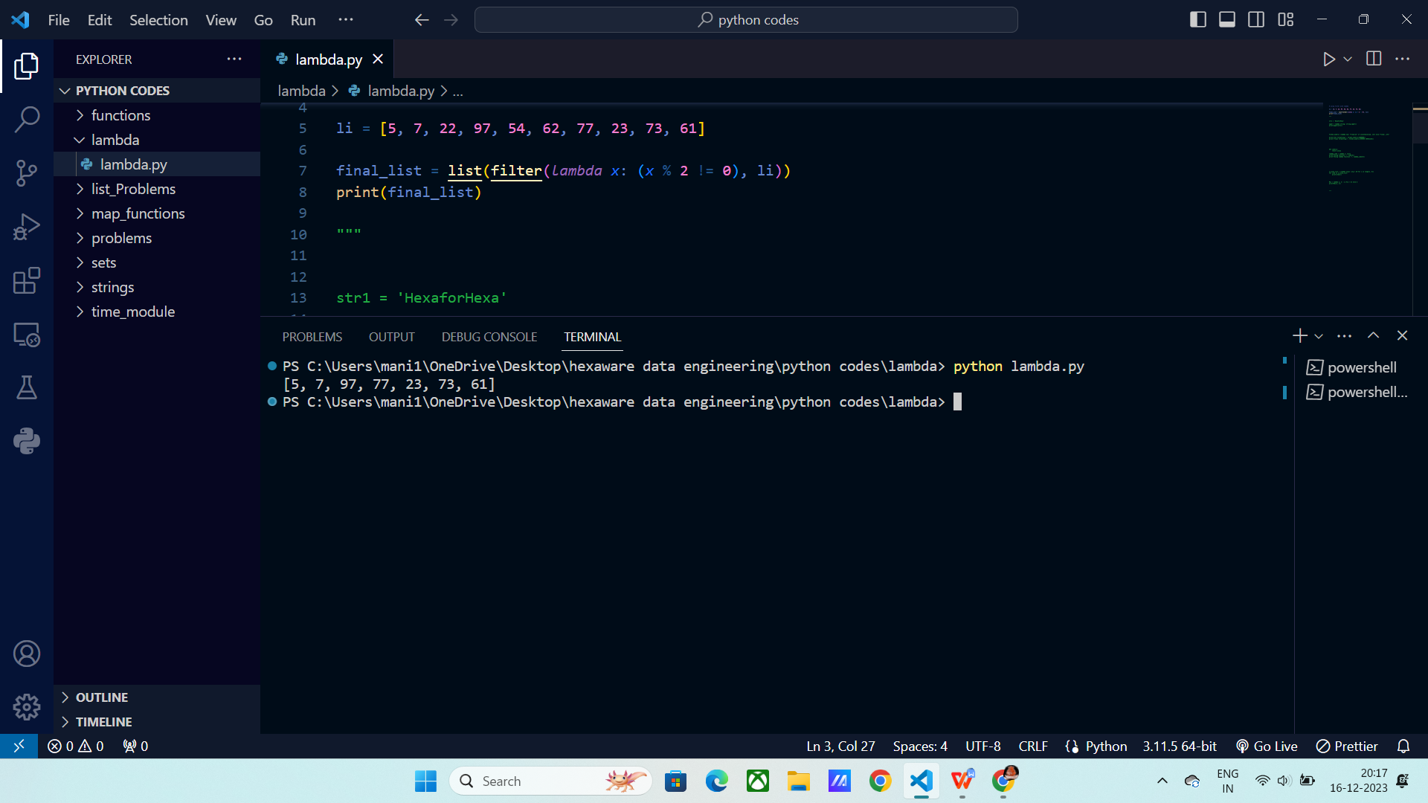

**Sum of numbers using * args :**

